JIMMY NELSON
HUMANITY
Palazzo Reale Milano
20 September 2023 – 21 January 2024

As a photographer, my journey revolves around the subject of my artworks: indigenous peoples. Through my work, which is rooted in a profound feeling of empathy, I seek to connect to people from different cultures and to inspire others to embrace the beauty of humanity, recognizing that we are all part of one people.
Jimmy Nelson

From 20 September 2023 to 21 January 2024, Palazzo Reale, Milan, will be hosting JIMMY NELSON. Humanity, a photography exhibition promoted by Comune Milano – Cultura, produced by Palazzo Reale and Skira Editore, in collaboration with the Jimmy Nelson Foundation, curated by Nicolas Ballario and Federica Crivellaro.

The exhibition will showcase 65 large-format photographs (up to 2 x 3m) from some of Nelson’s most famous cycles to document the creative evolution of this photographer, who has spent his entire life travelling all over the world in order to photograph some of the indigenous cultures at the greatest risk of disappearing, describing their customs and traditions, which have managed to survive in an increasingly globalized planet as well as giving room to their emotions.

Initially drawn to indigenous cultures as custodians of ancient wisdom and lore, as examples of resilience and rootedness, he gradually realized over the years that his work could help question and disperse some of the preconceptions associated with these ethnic groups.

“From an artistic point of view,” says Jimmy Nelson, “I am fascinated by the aesthetic of indigenous populations. Their brightly coloured clothing, their sophisticated crafts, and their breathtaking landscapes provide me with a rich visual tapestry to capture beauty through my lens.”

In his photographs, Jimmy Nelson celebrates the cultural diversity encountered on his journeys in contact with the myriads of communities in West Papua, Tibet, Africa, Siberia, Bhutan or in other zones of the planet, inviting viewers to see the world from a different perspective and encouraging them to understand and appreciate the intrinsic beauty we all possess as an integral part of the vast human family.

“I believe strongly in the transformative power of beauty,” continues Jimmy Nelson. “I have personal experience of how recognizing and celebrating beauty can bring about positive change in individuals and communities. When people are encouraged to embrace their own identities and unique values, they become more secure and fulfilled and a chain effect of positive transformation is generated in their lives.”

His work is typically expressed in the form of portraits. During his long sojourns in the remotest corners of the earth, Jimmy Nelson establishes deep connections with the people living there, paying meticulous attention to the cultural characteristics of the communities he portrays, emphasizing the uniqueness and beauty of every single one. His compositions are visual symphonies in which the human element harmonizes with the natural environment.

His images often portray the older members of these communities whose faces bear the signs left by time and lifetime of experiences, as in the photograph of the elderly Inuit woman.
Many of his portraits highlight the strength and beauty of women, as in the picture of the young Kazakh woman, a powerful symbol of female emancipation. His shots also document how women are also breaking down gender barriers in traditionally male activities, like hunting with eagles.

As Federica Crivellaro points out
“Another aspect of Jimmy Nelson’s photography is the representation of people in motion, involved in rituals, playing musical instruments, climbing rocks or riding horses. These images not only offer a glimpse of the cultures and lifestyles of the people involved, but also serve to immerse the viewer in a different culture in a prudent and respectful manner. The intention is to illustrate the dynamic influence of external factors like globalization, technology and popular culture on traditional societies and their evolving identities. Rather than documenting cultures from an ethnographic stance, he seeks to reveal their lively contemporaneity and the interaction between tradition and modernity.
An example of this is the image depicting a group of Dani from West Papua as they walk towards the viewer, wearing sunglasses and a mixture of traditional and non-traditional objects, including a framed diploma tied to an arm, exemplifying the mixture of non-traditional elements and typical tribal clothing.”

Another essential aspect of Jimmy Nelson’s art concerns the profound relationship between humanity and nature. The backdrops, whether valleys, mountains, plains, or waterways, seem to embrace the people portrayed. These subjects also transmit a sensation of deep respect, verging on reverence, for nature, becoming symbols of the protection of the environment and conveying the importance of sustainable practices for the conservation of nature.
Many of these large-format photographs depict groups of people standing beside or on top of tall, solidly rooted trees that symbolize power and stability, acting as a backdrop reflecting back the pride and trust of the subjects posing for his lens.

Jimmy Nelson’s works require enormous technical ability as well as great patience. The group scenes involve the coordination of multitudes of people, many of whom unfamiliar with the camera, who have to remain motionless for several seconds.
The stylistic perfection of his photographs is the result of years of research and experimentation. Drawing inspiration from two masters like Richard Avedon and Irving Penn, Jimmy Nelson approaches his subjects, paying attention to detail, using only natural light, and dedicating himself to revealing the true essence of the culture encountered.

After experimenting with analogue photography for many years, he began to use a large-format titanium view camera (10x8) for ease of transportation – also on display at the Palazzo Reale – and guaranteeing high image quality and outstanding resolution. This camera introduced a significant stage in his artistic evolution, allowing him to create images resembling paintings. A selection of this series of 10x8” photographs is on public display for the first time in this exhibition, along with the polyptych installations marking a new display approach being explored by the artist.

The exhibition will be held with the collaboration of TicketOne (ticketing partner), Ferrovie dello Stato (mobility partner), and StreetVox (technical partner).
Radio Monte Carlo is the exhibition’s official radio station.

The exhibition is accompanied by a large Skira catalogue containing a treasure chest of stunning images to store on your bookshelf.

From 4 to 19 September 2023, you can take advantage of the Early Bird special offer www.tickeone.it to buy an open ticket at at €10.00 instead of €17.00.

Biography of Jimmy Nelson
Jimmy Nelson was born in Sevenoaks, Great Britain, in 1967, but travelled the world almost immediately thanks to his geologist father’s job, which led to his family spending long periods in remote corners of Africa, America, and Asia. As an artist, he is constantly seeking to encounter and connect to indigenous cultures with the aim of celebrating their beauty and authenticity. His photographs are a mirror reflecting a naturally beautiful human essence interconnected to other humans and to all other living beings, where the relationship between humans and nature gives rise to reciprocal beauty. The images are created paying the maximum attention to detail, with an obsessive search for a balance of forms, colours, and, above all, light, which is exclusively natural. Since the time of his first internationally acclaimed photographs taken in Tibet almost 30 years ago, Jimmy Nelson has travelled to the furthest corners of our planet. In 2013, he published his first large book of photographs Before They Pass Away, followed in 2018 by Homage to Humanity. He has visited many indigenous communities all over the world, developing reciprocal projects through the foundation named after him. In 2022, he published a book paying homage to the traditional cultures in the Netherlands, Between the Sea and the Sky – a personal tribute to his adoptive country.

Milan, 19 September 2023

TECHNICAL SHEET

Title
Jimmy Nelson. Humanity

Venue
Palazzo Reale
Piazza Duomo, 12 - Milan

Dates
20 September 2023 – 21 January 2024

An exhibition
Palazzo Reale
Comune di Milano
Skira Editore

Exhibition curated by
Nicolas Ballario
Federica Crivellaro

Technical Partner
Street Vox

Ticketing Partner
TicketOne

Mobility Partner
Gruppo Ferrovie dello Stato Italiane

Official Radio
Radio Monte Carlo

Catalogue
Skira

Information and bookings
palazzorealemilano.it
jimmynelsonmilano.it
skira.net

Opening times
Tuesday-Sunday 10.00-19.30
Thursday 10.00-22.30
Monday closed
Last entry one hour before closing
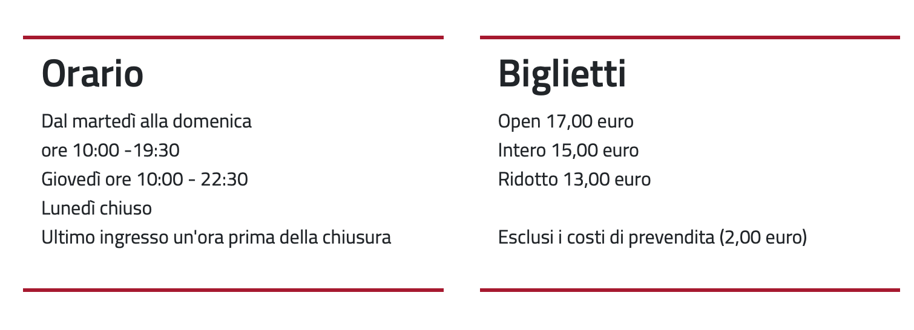
Tickets
Open 17 euros
Full 15 euros
Concession 13 euros
Excluding presales costs (2 euros)

Press office
CLP Public Relations| Anna Defrancesco | T +39 02 36755700 | M +39 349 6107625 anna.defrancesco@clp1968.it | clp1968.it

Comune di Milano Press Office
Elena Conenna elenamaria.conenna@comune.milano.it

