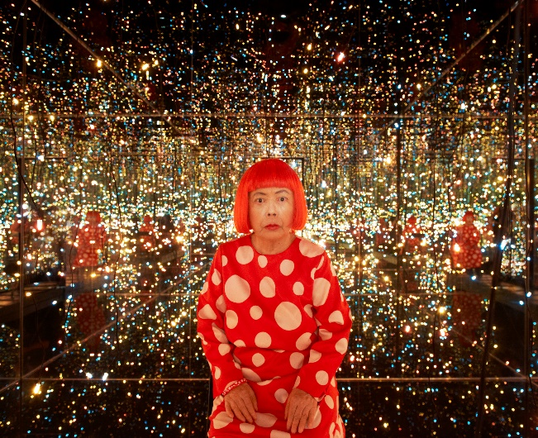
© Yayoi Kusama, Fireflies on the Water, 2002. Mirrors, plexiglass, lights, and water, 111 × 144 1/2 × 144 1/2 in. (281.9 × 367 × 367 cm). Whitney Museum of American Art, New York; purchase with funds from the Postwar Committee and the Contemporary Painting and Sculpture Committee and partial gift of Betsy Wittenborn Miller 2003.322. © Yayoi Kusama. Photograph by Jason Schmidt.

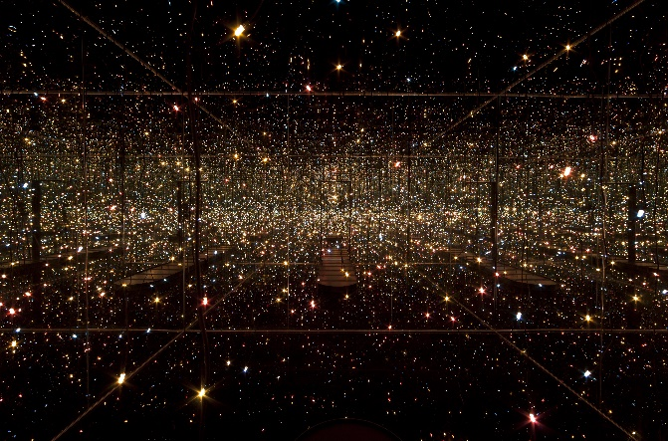
Yayoi Kusama, Fireflies on the Water, 2002. Mirrors, plexiglass, lights, and water, 111 × 144 1/2 × 144 1/2 in. (281.9 × 367 × 367 cm). Whitney Museum of American Art, New York; purchase with funds from the Postwar Committee and the Contemporary Painting and Sculpture Committee and partial gift of Betsy Wittenborn Miller 2003.322. © Yayoi Kusama. Photograph by Sheldan C. Collins
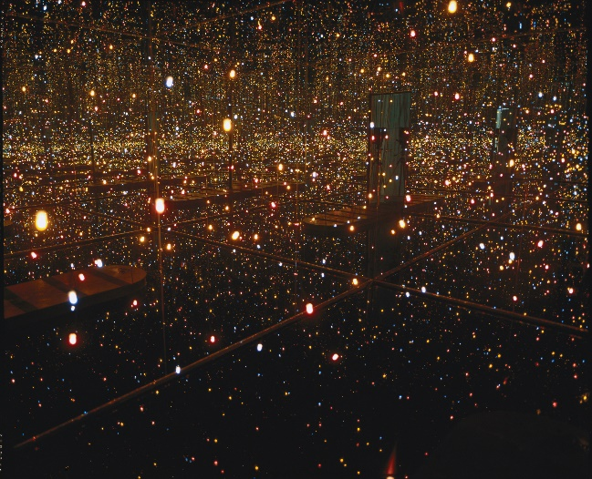
Yayoi Kusama, Fireflies on the Water, 2002. Mirrors, plexiglass, lights, and water, 111 × 144 1/2 × 144 1/2 in. (281.9 × 367 × 367 cm). Whitney Museum of American Art, New York; purchase with funds from the Postwar Committee and the Contemporary Painting and Sculpture Committee and partial gift of Betsy Wittenborn Miller 2003.322. © Yayoi Kusama. Photograph by Sheldan C. Collins

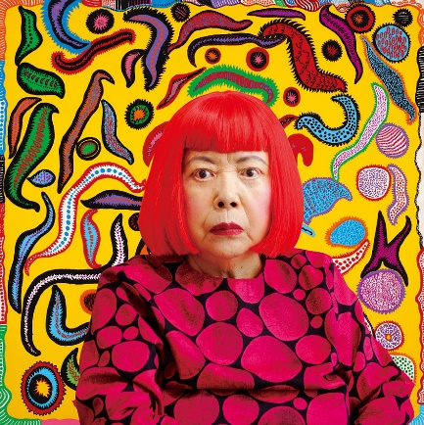
Yayoi Kusama, Portrait; ©YAYOI KUSAMA
Please see our regulations for reproduction below
- Please add the credit line ©YAYOI KUSAMA
- The photograph may not be bled, cropped, guttered, overprinted or altered in any manner.
- In the digital usage, add copy protection and 72dpi / width max 1600 px display
- Necessary to check the layout and the related text by the artist before printing / uploading at least a week before deadline.
*When you provide the images to the media
-please provide the above regulations
-please provide us the list of published media and a copy of the article or its link after the exhibition

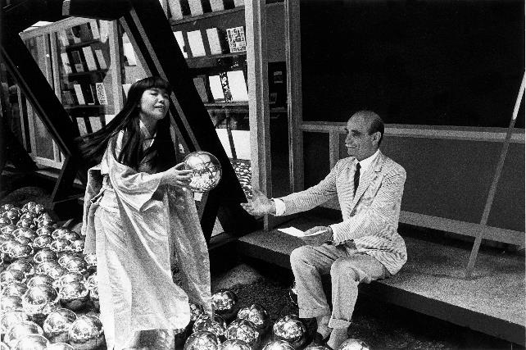
Venezia, 1966 - XXXIII edizione della Biennale d'Arte di Venezia. Gli artisti Yayoi Kusama e Lucio Fontana durante la performance (pirata) Narcissus Garden ai Giardini della Biennale.
©Gianni Berengo Gardin/Courtesy Fondazione Forma per la Fotografia

