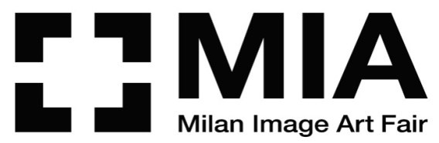

MILAN | SUPERSTUDIO MAXI
28 APRIL | 1 MAY 2022
MIA FAIR 2022
XI edition
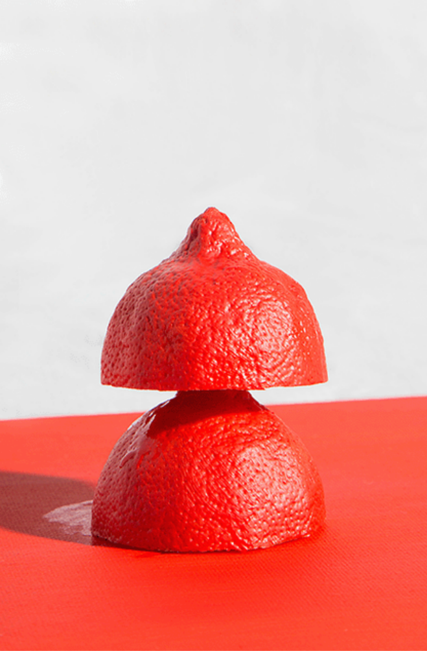
Larissa Ambachtsheer, Red Lemon, 2017, fine art print, Courtesy Project 2.0 / Gallery Den Haag

The Dutch artist Larissa Ambachtsheer signs the coordinating image for MIA Fair 2022

MIA Fair enters in the Fiere di Parma group

Main sponsor: BNL BNP Paribas

The spring of photography returns to Milan!
After the exceptional edition in autumn, MIA Fair – Milan Image Art Fair, the most prestigious Italian fair, completely dedicated to photographic images, comes back from 28th April till 1st May 2022.
It will once again be SUPERSTUDIO MAXI in Milan (via Moncucco 35), in zona Famagosta that hosts the XI edition and 97 exhibitors from Italy and abroad, who will bring the best of the photography world to Milan.
MIA Fair will therefore be a place to deepen and amplify the disciplinary fields that it aims to face, concentrating on research and the transversability of the artistic contemporary languages.

As of this edition, MIA Fair is part of the Fiere di Parma group.
“After several years of collaboration during which we were able to verify our elective affinities – says Antonio Cellie, CEO of Fiere di Parma-, we have welcomed with enthusiasm the availability of the Castelli family to become their shareholders to work together on the project of developing and improving MIA Fair’s international exposure. Already from 2023 we have planned several important appoinments abroad which will strengthen the relationship between MIA Fair and its community of buyers and collectors”.

“It was very important to us – highlight Fabio Castelli and Lorenza Castelli, the creators of MIA Fair – that MIA Fair were to move back to its usual spring atmosphere. As a result, having only a few months available to work, we were able to organise a new edition of the fair which will propose, as has always happened in the previous years, many interesting novelties”.
“Let’s consider what we are about to inaugurate – continue Fabio Castelli and Lorenza Castelli – the zero edition of a new adventure which will see us unite our forces with Fiere di Parma with the aim of giving ulterior impulse to the photography market, and to attract the investments not only of collectors and international buyers, but also to stimulate the interst of the public that is passionate about art and, in particular, photography.

After Rankin, this year it’s the turn of the Dutch artist Larissa Ambachtsheer (1993) to sign the coordinating image of MIA Fair, with images from the series You Choose, I seduce (2017), in which she mimics human behavious by creating scenes, to realise dead natures, questioning the role of colour in food and how it can be used as an instrument of manipulation.

The mosaic of MIA Fair is made up of numerous tiles. The most relevant, and the heart of the entire fair, is represented by the Main section which will house a panel of exhibitors, selected by Fabio Castelli, the director of MIA Fair, Gigliola Foschi and Enrica Viganò, advisors for MIA Fair.
From the various sections, the confirmation of Beyond Photography – Dialogue is highlighted, curated by Domenico de Chirico, who has selected with the invited galleries consolidated and emerging artists, in a dialogue between photographic works understood and languages of contemporary art and other mediums such as sculpture, painting and installation.

MIA Fair can count on a fond group of sponsors.
For the 11th consecutive year, BNL BNP Paribas is a partner of MIA Fair with the role of Main Sponsor, promoting the BNL BNP Paribas Award, that of the highest importance of the event, assigned by a jury to artists that take part in the fair, exhibiting with their referenced galleries. This recognition highlights the strong interst of BNL BNP Paribas in the development of culture and in the search for contemporary art in Italy. The winning artwork will be announced on 27th April and it will be bought by BNL BNP Paribas to be a part of the bank’s collection, which as of today is made up of over 5000 works.

Eberhard & Co., which has accompanied MIA Fair for 10 years, also confirms its support and proposes a new project for the disclosure of a part of the archive of Adriano Scoffone (1891-1980) containing around 40 000 plates and films created by the photogrpaher from Piedmont, as well as the simultaneous digitization into a database that can be consulted online.
At MIA Fair the show Quei temerari delle strade bianche. Nuvolari, Varzi, Campari e altri eroi alla Cuneo - Colle della Maddalena will take place, curated by Giosuè Boetto Cohem, with the support of Eberhard & Co., which will, using a selection of 20 images, tell the story of the automotive challenge Cuneo-Colle della Maddalena, from 1925 and 1930, considered one of the most dangerous courses of the era due to its difficulty and length. A fundamental person in the photography and the exhibiiton is Tazio Nuvolari, one of the most famous names in motoring worldwide and to whom, for over 30 years now, Eberhard & Co. dedicates a special collection.

THE PRIZES
Since the first edition, MIA Fair has stood out thanks to the quality and the variety of the proposals and the prizes, born from the precious collaborations with various institutions and cultural partners.
Among these, the New Post Photography Award stands out, organised by MIA Fair, curated by Gigliola Foschi, which proposes to promote the most creative and innovative tendencies of the world of contemporary photography and to be a signficiant window, capable of registering and shining a light on current changes.
The jury, made up of Gigliola Foschi (curator of the Award and Advisor to MIA Fair), Sara Benaglia and Mauro Zanchi (teachers, curators of BACO – Base Arte Contemporanea Odierna di Bergamo), Matteo Bergamini (director responsible for exibart, member of the curatorial team of the biennale of contemporary art in Milano “BienNoLo”), Steve Bisson (artistic director of Ragusa Foto Festival, teacher at the Paris College of Art), Franco Carlisi (director of the magazine “Gente di Fotografia”) and Claudio Composti (curator and artistic director of mc2 gallery), have selected Giorgia Bisanti, Mitikafe, Alessandro Cristofoletti, Daria Danilova, Francesca De Pieri, Massimiliano Gatti, Alessandro Laita / Chiaralice Rizzi, Marco Lanza, Nikola Lorenzin, Libera Mazzoleni, Sara Munari, Giangiacomo Rocco di Torrepadula, Alessandro Sambini, Filippo Tommasoli, Ulderico Tramacere, whose works will be exhibited during MIA Fair, in a dedicated space.

MIA Fair 2022 welcomes the first edition of the IRINOX SAVE THE FOOD Award, curated by Claudio Composti, open to projects of artists that have a relationship with the theme of food in all its forms.
From the many candidates, the finalists were selected by the jury made up of Katia Da Ros (entrepreneur and Vice President of Irinox S.p.A., Conegliano, TV), Carlo Sala (curator and art critic) and Enrico Stefanelli (Director of Photolux Festival, Lucca). The 3 finalists of the Award are:
Margherita del Piano, Malena Mazza e Maurizio Montagna and 13 other artists, whose works will be exhibited at the Fair: Simone Barberis, Giulio Cassanelli, Arnaldo Dal Bosco, Alessia De Montis, Margherita Del Piano, Mario Ermoli, Silvia Gaffurini, Giacomo Giannini, Luca Gilli, Ziqian Liu, Rohn Meijer, Ryan Mendoza, Romana Zambon, Patrizia Zelano.
The jury has decreed that Malena Mazza, Margherita Del Piano and Maurizio Montagna, as winners of the Award, and the artwork Convivio by Malena Mazza, will become part of the Irinox collection, thanks to the acquisition prize.
The Award is supported by Irinox S.p.A., leader in the production of rapid blast chillers and conservation systems of high quality for the professional and domestic sector and of electric switchboards in inox steel.

Sky Arte, media partner of MIA Fair, promotes the Sky Arte Award which will be assigned to one of the photographers present at the Fair, with a special transmitted on the themed channel completely dedicated to the artist’s career and their artistic vision up for grabs.
The jury is made up of Fabio Castelli, creator of MIA Fair, Francesco Raganato, author and director, Daria Scolamacchia, photo editor and coordinator of the IED department of Rome, and Dino Vannini, Head of Documentary and Factual Channels of Sky.
Furthermore, Sky Arte now has a service on MIA Fair which will be diffused on the channels 120 and 400 of Sky and will be in streaming on NOW.

THE SPECIAL PROJECTS
Beyond the Main section and the awards, MIA Fair is completed with a series of special projects.

BDC – Bonanni Del Rio Catalog, a cultural pole of Parma (acronym of the collector couple from Parma Lucia Bonanni and Mauro Del Rio and ‘C’ of catalog) promotes the first edition of the New Italian Choice, which aims to add value to the works of three artists that have been selected as heirs of the great masters of italian photography. The winning artists, beyond a monetary prize, will exhibit their works at MIA Fair 2022 and, in autumn, in the BDC headquarters at Parma.

Furthermore, Fiere di Parma have provided a fund of 20 000 euros to use for the acquisition of the works selected during the days at MIA Fair, from a commission made up by Fabio Castelli and exponents of CSAC – The Centre of Studies and Archives of Communication of the University of Parma, founded by Carlo Arturo Quintavalle, which will become part of the collection of Fiere di Parma.

SNAM, main european operator in transport and storage of natural gas, promotes The Thin Line, a project that documents the 4000km long photographic journey, undertaken by Giada Ripa in Italy, from the extreme North in Friuli Venezia Giulia to Mazara del Vallo in Siciliy, in which the territory hosts networks and infrastructure that are respectful of the natural and human environment, across which flow green gases such as hydrogen and biomethane, capable of bringing people ever closer to the sources of renewable energy.

The Centre of Research of Advanced Technology in Health and Well-Being and ICONE, the European Centre of Research of History and Theory of Images of the University of Vita-Salute San Raffaele return to MIA Fair with Neffie, a project of Neuro-Aesthetic Photography that unites photographic art and technological innovation and a cycle of cultural meetings dedicated to reflecting in a broad sense on this relationship.
NEFFIE refreshes the iconic photobooth used by Franco Vaccari in his photographic artworks that took form in real time, Exposure in real time n. 4: Leave a photographic trace of your passage on these walls, Presented at the Venice Biennale in 1972, making it the protagonist of that which could define itself a new virtual exposure in real time and showing the actual anticipator of concepts of ‘feedback’ or ‘technological unconsciousness’.
In particular, NEFFIE uses specific biosensors and a complex algorithm of Artificial Intelligence to elaborate the emotive and cognitive responses of visitors in front of a complex photograph, returning a tangible representation of that which we have seen and perceived before this as a concrete symbol of our ‘unconscious neuro-aesthetic’. After the positive feedback received at MIA Fair in October 2021, the platform reopens to the public offering the space for a new experiment in first person, reaffirming the centrality of the photographic medium as a central artistic device or cultural emancipation and knowledge, both individual and social.

The Olympic Foundation for Culture and Heritage presents Olympism Made Visible, an international project of photography to divulge the olympic values, through development initiatives on a community basis in sectors such as humanitariam assistance, the promotion of peace, of health and wellbeing in sport.
In honour of the occasion, the images of Alex Majoli and Lorenzo Vitturi, who worked with organisations in Brasil and Cambodia and promote social development through sport, will be exhibited for the first time in Italy and in a European photography fair.
Alex Majoli, one of the most recognised photo-reporters of war, proposes 33 shots collected during his visit with two organisations operating in the Favelas of Rio De Janeiro, while Lorenzo Vitturi, a visual artist, photographer and sculptor, exhibits 12 images inspired by his meeting with the skateboard school for children in the poorer peripheries of the Phnom Penh in Cambodia.

Roberto Polillo, one of the most well-known italian photographers on an international level, brings his project Invisible to MIA Fair.
Curated by Denis Curti, Invisible tells the story of the Milanese artist, across 21 images which reflect over 15 years of photographic investigation which in the first few years of of his career allowed him to portray some of the most important names in jazz, and so, moved by his love of travel, it pushed him into over 25 countries aroun the world, from Morocco to Cambodia, from Japan to India. The artworks exhibited at MIA Fair present landscapes and architecture, colours and perceptions, which aspire to grasp the soul of places and reveal a reality reduced to its essential elements, evocative of a reality different to that seen only by eyes and at the will of finding a language that can become a new vehicle of the expression of reality.

The project will complete with the talk on Friday 29th April at 18:00 titled Exploring the Invisible which will see a dialogue between Denis Curti and Alberto Diaspro, director of the Department of nanophysics of the Italian Institute of Technology, with Mauro Pagani, multi-instrumentalist, composer and discographic producer, and Francesca Taroni, director of Living e Abitare.

Animica is the title of the special project of Barbara Pigazzi, curated by Angela Madesani.
The protagonist is the Venetian lagoon between the provinces of Padua and Venice, a heritage of UNESCO. The show presents 16 images, printed on Hahnemühle paper, which propose an anthropised landscape, on which the photographer has worked for many years. The locations are theatres of brief stories of the soul, populated by characters, men and women, where the poetic choices of the light and the silence of nature dominate. For the occasion Barbara Pigazzi has created a portfolio of 7 specimens, made up of the 7 most signficant images of Animica.

The Gallery Project 2.0 of L’Aia (the Netherlands), with the project Dutch Talent Pavillion, with the heritage of the Consulate of the Kingdom of the Netherlands, has chosen the showcase of MIA fair to present 5 of the most original photographers of the new Dutch contemporary scene: Sanja Marušič, Manon Hertog, David Hummelen, Lisanne Hoogerwerf and Larissa Ambachtsheer that has signed the images of the fair. The five artists propose as many visions of everyday life which develop in a naration made up of images connected between themselves.

Once again MIA Fair strengthens the collaboration with Photo Independent, the photography fair in Los Angeles that probes the new generations of independent photographers which, for the occasion, will present an immersie show and a selection of the most interesting artists, chosen from the many that have exhibited in the Californian review.

Wave in the Forest. The Invisible that exists is the photogrpahic project of Marco Lanzetta Bertani, created and curated by Claudio Composti, in collaboration with Tenuta de l’Annunziata di Uggiate Trevano (CO), a Natural Relais born from the recovery of an old property abandoned a long time ago, inserted in a wooded area of 12 hectares, mapped out by the bio architect Marco Nieri, in which one can use the mediative paths guided by Margot Errante, a teacher of contemplative Asian disciplines.
The exhibit was born form the knowledge that the binomial of nature-man is as timely as ever and the photographs of Marco Lanzetta Bertani, always dedicated to the theme of the forest, make up the key of unpublished literature to recount the relationship of man-tree. For Lanzetta, photographing the woods and the forests means opening a ‘portal’, to enter through the images in an introspective state and to begin a journey within oneself, in a place where one meets the conscious and the unconscious.
On Saturday 30th April at 18:00 in the Area Talk of MIA Fair there will be a conversation between Marco Lanzetta Bertani, Margot Errante and Marco Nieri.

Mondadori Portfolio – the photography agency of the Mondadori Group – celebrates its first 10 years of activity with Uno sguardo gentile, fotografie di Marisa Rastellini, a monographic curated by Maria Vittoria Baravelli in collaboration with Mondadori Portfolio, dedicated to refined photography that she has worked on, from the 1960s until the end of the 1980s, for the magazine Grazia and Epoca.
The vintage prints of Marisa Rastellini will be exhibited, in a way to perfectly document the spirit of the time that she lived through to represent it well through her portraits of actors, literature figures and of Italian culture, and in the numerous fashion reportages. A photographer of deep gaze, her extraordinary works are made visible from the Mondadori Archives for the first time.

At MIA Fair Morpheus will be presented, a project develped by Bit For Fun that proposes the best of technology to apply to the metaverse and to show galleries art works and NFT in a personalised scenario, with a level of definition and of realism never seen until now. As a result, visitors will have the possibility to try the functions of Morpheus, virtually accessing galleries in real time.

With this edition, MIA Fair begins a collaboration with Instagrammers Milano (@IgersMilano), the Milanese community for those passionate about Instagram, with over 54 000 followers, which translates into two initiatives. The first is a workshop in which Orazio Spoto, an expert of digital communication, co-founder of Newmi B Corp and president of Instagrammers Italia ETS, will talk about “Instagram and photography: 10 profiles to inspire you” thus creating examples and useful ideas for professional people and curious people.
The second is a challenge, or better a ‘photography challenge’ on instagram open to all in which it asks people to represent with a photograph ‘love’, in all its forms, inclusive and supportive, and to highlight it with the tag #AmoreMiaFair. A jury overseen by the photographer Stefano Guindani will selected the most interesting which will then be exhibited at the fair and sold for charity in collaboration with the Fondazione Rava.
The Fondazione Rava also presents a project, Emergenza Ucraina, told through the intense images of Alfredo Bosco, photo-reporter of the LUZ Agency and a volunteer of the Foundation in Haiti. From the first day of the conflict, Alfredo Bosco has found himself in Ukrainian territory, continuing to testify the grave situation through his photographs.

As an ideal prologue to the fair, MIA Fair is organising, from 11th April till 19th September 2022, in the dedicated spaces for art photography in Bocconi University of Milan, the exhibit Ganga Ma (Madre Gange), which documents the ten-year-long journey along the sacred river that the italian photographer Giulio Di Sturco undertook reporting the effects of pollution, industrialisation and climate change. The project accompanies the river for 2500 miles, from the source in the Himalayas in India to the delta in the Bay of Bengal in Bangladesh, recounting how it found itself suspended between the humanitarian crisis and the ecological disaster.

L’Archivio Carlo Orsi presents itself at MIA Fair with an exhibit that retraces the career of the milanese photographer, across 30 images drawn from his most famous cycles, from the most iconic ones dedicated to Milan in the 1970s to those of his travels around the world, from shots of people of culture such as Riccardo Muti and Ettore Sottsass, of sport – Michael Schumacher, Marco Simoncelli and others.

Another flower at the eyelet of MIA Fair is its Cultural Programme which, in the opening days of the event, will organise meetings, conferences, talks on a few of the most current themes in the field of art and of photography.

MIA Fair – Milan Image Art Fair, organised by Fiere di Parma, enjoys the patronage of the Region of Lombardy, of the Metropolitan City of Milan, of the Comune of Milan, and of the Kingdom of the Netherlands. Main sponsor BNL BNP Paribas. Sponsor Eberhard & Co.

Biography Larissa Ambachtsheer (1993)
She lives and works in L’Aia (Holland), she graduated in 2017 from the Royal Academy of Visual Arts of L’Aia.
Her work concentrates on themes connected to the human behaviour, such as knowledge, minimalist style of life and sustainability. She observes that which happens in everyday life and she transforms it into her reality. This translates into dead nature, creations of fashion and series of photographic images.
With these works, Larissa Ambachtsheer highlights the manipulatory mechanisms, social and automatic that often control the relationship between ourselves and our lives.

Milan, 7th April 2022

MIA Fair | Milan Image Art Fair 2022
SUPERSTUDIO MAXI
Milano, Via Moncucco 35 (MM Famagosta)
28th April – 1st May 2022

Inauguration by invitation: Wednesday 27th April 2022 from 17:00 till 22:00
Open to the public from Thursday 28th April till Sunday 1st May 2022

Tickets:
Full price: 16 euro
Reduced: 12 euro (students up to 21 years of age, over 65)
Reduced evening: 12 euro after 18:00
Affiliated entities: 10 euro
Affiliated universities: 10 euro
Free entry for disabled people and children up to 14 years of age

Information:
Organisation Secretary MIA Fair
Tel. +39 02 83241412
info@miafair.it
www.miafair.it

Press office Fiere di Parma
Antonella Maia Communications
Antonella Maia | M 3494757783 | press@antonellamaia.com | www.antonellamaia.com

Press Office MIA Fair
CLP Relazioni Pubbliche
Anna Defrancesco | T +39 0236755700 | M 3496107625

Communicatons and images on www.clp1968.it

