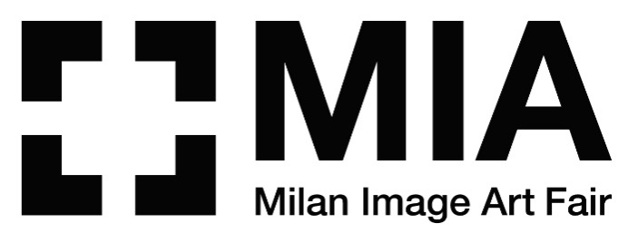

**MIA FAIR 2021**

**A SUCCESSFUL BET**

**A CONSTANT FLOW OF VISITORS IN THE NEW LOCATION OF SUPERSTUDIO MAXI AND A GOOD SALES RESULT FOR THE MOST IMPORTANT ITALIAN FAIR DEDICATED TO PHOTOGRAPHY.**

**ANNOUNCED NEW DATES FOR THE NEXT EDITION: MIA FAIR RETURNS IN SPRING TIME, FROM APRIL 27th TO MAY 1st 2022**

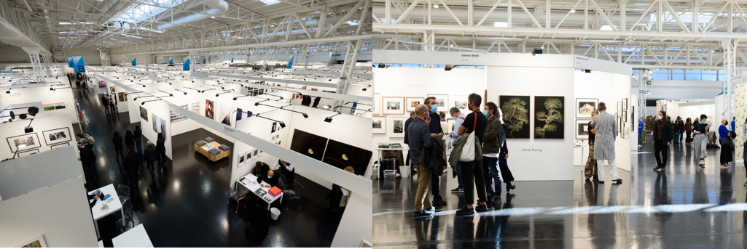

**MIA Fair 2021, Superstudio MAXI** © Giulia Virgara

**Press kit and images at:** [**https://bit.ly/2UH4RML**](https://bit.ly/2UH4RML)

**It’s already time to take stock of the tenth edition of MIA Fair, the most important Italian fair dedicated to photography, directed by Fabio Castelli and Lorenza Castelli, held in Milan from 7 to 10 October 2021.**

Many novelties to celebrate the 10th edition of MIA Fair. The most striking one was the new locationat SUPERSTUDIO MAXI, in the Famagosta district, which has been warmly welcomed both by the exhibitors and by the public who were able to enjoy in full safety and in great comfort the proposals of the 90 Italian and international galleries, in a large area of more than 7,000 m².

The organizers have already announced **the date of the next edition, which returns to the usual spring schedule: from April 27th to May 1st, 2022.**

“In recent months - **states Fabio Castelli**, creator and director of MIA Fair – my daughter Lorenza and I have often wondered whether to organize the 2021 tenth edition or postpone it until next year. The pressing requests from gallery owners and the improved conditions of the measures to contain the epidemic led us to decide for this Autumn. Then, we thought about how to organize it, and we agreed that we could not set it up as the previous ones, and we decided to take some risks: we changed the location by moving to the south of Milan, we enriched the contents of the fair with a section in which photography and design dialogued together. At the same time, we expanded the number of prizes and improved the cultural program by making it extremely multifaceted and diversified, in order to help the public to thoroughly understand the photographic image through round tables held byart critics or historians, also involving other forms of knowledge such as in the "Art and Science" format. As a result, our long lasting efforts allowed the audience to get closer and closer to the photographic image, edition after edition, and let the public become increasingly more conscious on purchases as art collectors. And this, too, makes us think that we won the bet!".

"For this result we thank first of all our partners: **BNL BNP Paribas Group** (Main Sponsor), and **Eberhard & Co**. (Sponsor). We also thank for their collaborations our new curators **Valerio Castelli, Caterina Mosca, Nicola Quadri, Paul Jackson Gallery, Sofia Rudling and Alessandro Stefanini** for the new section **MIDA - Milan Image Design Art**; and **Domenico de Chirico for Beyond Photography - Dialogue**, and **Gigliola Foschi** as curator of the exhibition and member of the jury of the **New Post Photography award**."

Many deals were closed during the four days of MIA Fair. Among these, the results of **Atelier Relief**, with 7 works sold between €2,800 and €7,500 with Gustav Willeit as the top selling artist, or that of **Galleria Valeria Bella**, with seven works (from €900 to €1,600), including those of Federica Belli (Mondovì, CN, 1998) who with *The Eye* (2020) won the BNL BNP Paribas Group Prize.

Also **Fine-Art Images Gallery** with 7 works (from €6,000 to 7,000), by authors such as Stefania Romano, Andrea Cittadini, Alain Noguès, Giorgio Gatti, **Galleria Gaburro**, with 5 works (from €13,000 to €18,000) as an excellent response to the works of the Chinese Liu Bolin, **29 ARTS IN PROGRESS** with 5 works by the British photographer Rankin who has curated the coordinated image of the fair, or **BIANCHIZARDIN CONTEMPORARY ART**, with the exhibition project “Out of The Box” by Caroline Gavazzi composed of 12 photographs-sculptures (unique pieces), entirely sold (from €600 to 1,500 per piece).

Milan, October 2021

**MIA Fair | Milan Image Art Fair 2022**

Milano, SUPERSTUDIO MAXI (via Moncucco 35 - MM Famagosta)

**27th April – 1st May 2022**

**Contacts:**

**MIA Fair**

Tel. +39.02.83241412

[info@miafair.it](mailto:info@miafair.it) - [www.miafair.it](http://www.miafair.it/)

**Press Office - CLP Relazioni Pubbliche**

Stefania Rusconi | tel. +39.02.36755700 | [stefania.rusconi@clp1968.it](mailto:stefania.rusconi@clp1968.it) | [www.clp1968.it](http://www.clp1968.it)

**Press release and images** [**www.clp1968.it**](http://www.clp1968.it)

**The guiding image of the show signed by photographer Rankin may not be published without the written consent of the Artist.**

**Requests should be received at:** [**stefania.rusconi@clp1968.it**](mailto:stefania.rusconi@clp1968.it)

**RANKIN PHOTOGRAPHY LTD TERMS & CONDITIONS FOR USE OF DIGITAL IMAGES AND FILMS**

**USAGE**

Image(s)/film(s) are to be used for agreed purpose only. Any further usage beyond agreed purpose will incur a fee.

By using these image(s)/film(s) you agree to indemnify and hold harmless Rankin, his successors, Rankin Photography Ltd. and any licensees from and against any loss, damage or expense incurred or suffered by or threatened against any of them by reason of your usage.

**SHARING/SYNDICATION**

There is no right to share or disseminate the files received nor is there any right to print, display or use images beyond their original purpose - whether for public or personal use.

Any further publishing, transmission or syndication of the image(s)/film(s) must be cleared with Rankin Photography Ltd. This includes use for promotional purposes and on social media sites.

All requests for usage of images, descriptions and biographical information from third party contacts must be directed on to Rankin Photography Ltd.

**COPYRIGHT**

Any electronic image(s)/film(s) supplied remain the exclusive property of Rankin Photography Ltd and are protected under international copyright laws. Rankin Photography Ltd retains the entire copyright of these image(s)/film(s) at all times throughout the world.

**MANIPULATION/EDITING**

Manipulation of the image(s)/film(s) is strictly prohibited without the permission of Rankin Photography Ltd. Editing of the image(s)/film(s) is allowed for technical purposes only.

**CREDIT**

Credits to accompany the image(s)/film(s) must be as specified in writing by Rankin Photography Ltd. Rankin Photography Ltd is to approve any use of Rankin’s name, likeness and/or works.

If approval has been obtained for social media sharing of the image(s)/film(s) all posts must credit Rankin, along with all other band/agency credits as required:

Twitter: @rankinphoto Facebook: @RankinPhotographyLtdInstagram: @rankinarchive Vero: @rankin

**ELECTRONIC STORAGE**

Once used for agreed purpose, image(s)/ film(s) must be deleted from your company computers and/or internal digital database.

No part of these image(s)/film(s) may be reproduced, stored in a retrieval system or transmitted in any form by any means electronic, mechanical, photocopied, recorded or otherwise, without prior written permission of the copyright holder.