MILAN | MIA FAIR 2021

NEW DATES
7 | 10 OCTOBER
NEW VENUE
SUPERSTUDIO MAXI
NEW VISUAL CAMPAIGN
RANKIN

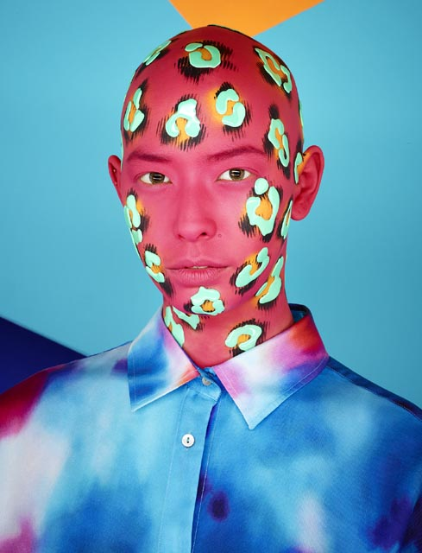

© RANKIN, Blue Leopard – Pink, Saved By The Bell series, 2018 / Courtesy of 29 ARTS IN PROGRESS gallery

Celebrating the 10th anniversary, MIA Milan Image Art Fair, the international art fair dedicated to photography, directed by Fabio Castelli and Lorenza Castelli, has been rescheduled from Thursday 7th to Sunday 10th October at the new venue SUPERSTUDIO MAXI (Via Moncucco 35) in Milan.

The decision to postpone MIA Fair to autumn 2021, after the forced cancellation of the 2020 edition, is due to the need to ensure the best safety conditions possible for visitors and exhibitors, considering the effectiveness of the global vaccination campaign, and to the opportunity to seize the impacts of the expected economic rebound.

The new venue SUPERSTUDIO MAXI, 7,400 sq.mt.covered area available,willensure to comply with social distancing rules within the anti-Covid19 regulations and will provide new space for further expanding the disciplinary fields of MIA Fair. Following the successfulMIA&D Singaporeexperience, held in 2014 at Marina Bay Sands in Singapore, where, for the first time in the world, an art fair presented a dialogue between photography and design, this year MIA Fair will showcase for the first time in Milan a section devoted to historical, modern and contemporary art design in conjunction with fine art photography works, highlighting the harmony between these contemporary art languages.

Among the novelties, MIA Fair will propose a vintage and rare prints tour among the exhibitors’ booths, to respondto the requests of collectors, whose passion for historical works and for vintage and rare prints has continuously increased.

Until next May 15th Galleries are welcomed to apply to participate to the Main Section and to the new MIA&D – Photography Art& Design Section. The projects submittedby the Galleries will be examined by the Selection Committee.

MIA Fair 2021 relies on the support of the Main Sponsor BNL BNP Paribas Group and the Sponsor Eberhard & Co. and on the patronage of Comune di Milano, Regione Lombardia e Città Metropolitana di Milano.

During its nine-year history, MIA Fair has grown considerably, not only as an exhibition event, but above all as a cultural platform, particularly focused on showing the latest developments in the photography field. At the same time, MIA has deepened the knowledge of photography as contemporary art language among visitors and enthusiasts, as well as professionals and collectors. MIA Fair is internationally recognized as a benchmark art fair for its high quality and organizational standards.

The 2019 edition of the fair welcomed 25,000 visitors, 135 exhibitors including 85 galleries, from 17 countries, 28 specialized publishers, 5 special exhibitions, 21 conferences.

The British photographer Rankin has been invited to give a new “visage” to the first Italian fair dedicated to fine-art photography, through a series of images selected from his project Saved by the Bell.
As for the past two editions, regarding its visual communication campaign, MIA Fair has decided to engage with a prominent international photographer.
Rankin is a photographer with a very extensive portfolio ranging from documentary photography to portraits. Throughout his long career, he has always distinguished for his bold approach behind the lens, following an artistic inspiration that has given life to vivid images and portraits that are a legitimate part of contemporary photographic iconography.
Rankin is an eclectic artist who has constantly been at the forefront in every stage of his artistic development, including as co-founder of the magazine Dazed and Confused and as a film director.
In each of his roles, he has followed both his well-known inclination towards innovation and his audacious style. Rankin’s approach in expressing his unorthodox creativity is inspired by a wide range of different tools, such as the use of textures and colours, which he places around his subjects to create strange and unexpected forms.
Rankin’s project Saved by the Bell, created for Hunger Magazine, in collaboration with make-up artist Andrew Gallimore, combines marked references to the culture of the 80’s and 90’s, through the use of pop colours and graphic patterns, with a cutting-edge style emphasised by the inclusion of three-dimensional elements applied to the faces of the subjects.
While clearly referring to the past (also in the title itself, Saved by the Bell, which is the name of a famous American sit-com from the late 80’s), the project effectively conveys an intention to reinterpret the period through a re-elaboration of key elements (colours and patterns) which characterisesthe decade.
Rankin presents, therefore, a unique visual narrative capable of capturing the aesthetics and characteristics of an era.

Milan, February 2021

MIA Fair | Milan Image Art Fair 2021
SUPERSTUDIO MAXI
Milan Famagosta (via Moncucco 35)
7 – 10 October 2021

Inauguration by invitation only: Wednesday 6th October 2021

Information:
MIA Fair Organization Office
Via San Vincenzo 22 - 20123 Milan | Tel. +39.02 . 83241412
info@miafair.it - www.miafair.it

Press office
CLP Public Relations
Stefania Rusconi | tel. +39. 02.36755700 | stefania.rusconi@clp1968.it | www.clp1968.it

Press Release and images www.clp1968.it
The images for printing use will be not published without the written consent of the Artist.
Requests must be sent to: stefania.rusconi@clp1968.it

RANKIN PHOTOGRAPHY LTD TERMS & CONDITIONS FOR USE OF DIGITAL IMAGES AND FILMS
USAGE
Image(s)/film(s) are to be used for agreed purpose only. Any further usage beyond agreed purpose will incur a fee.

By using these image(s)/film(s) you agree to indemnify and hold harmless Rankin, his successors, Rankin Photography Ltd. and any licensees from and against any loss, damage or expense incurred or suffered by or threatened against any of them by reason of your usage.
SHARING/SYNDICATION
There is no right to share or disseminate the files received nor is there any right to print, display or use images beyond their original purpose - whether for public or personal use.

Any further publishing, transmission or syndication of the image(s)/film(s) must be cleared with Rankin Photography Ltd. This includes use for promotional purposes and on social media sites.
All requests for usage of images, descriptions and biographical information from third party contacts must be directed on to Rankin Photography Ltd.
COPYRIGHT
Any electronic image(s)/film(s) supplied remain the exclusive property of Rankin Photography Ltd and are protected under international copyright laws. Rankin Photography Ltd retains the entire copyright of these image(s)/film(s) at all times throughout the world.

MANIPULATION/EDITING
Manipulation of the image(s)/film(s) is strictly prohibited without the permission of Rankin Photography Ltd. Editing of the image(s)/film(s) is allowed for technical purposes only.

CREDIT
Credits to accompany the image(s)/film(s) must be as specified in writing by Rankin Photography Ltd. Rankin Photography Ltd is to approve any use of Rankin’s name, likeness and/or works.
If approval has been obtained for social media sharing of the image(s)/film(s) all posts must credit Rankin, along with all other band/agency credits as required:
Twitter: @rankinphoto Facebook: @RankinPhotographyLtdInstagram: @rankinarchive Vero: @rankin
ELECTRONIC STORAGE
Once used for agreed purpose, image(s)/ film(s) must be deleted from your company computers and/or internal digital database.

No part of these image(s)/film(s) may be reproduced, stored in a retrieval system or transmitted in any form by any means electronic, mechanical, photocopied, recorded or otherwise, without prior written permission of the copyright holder.

