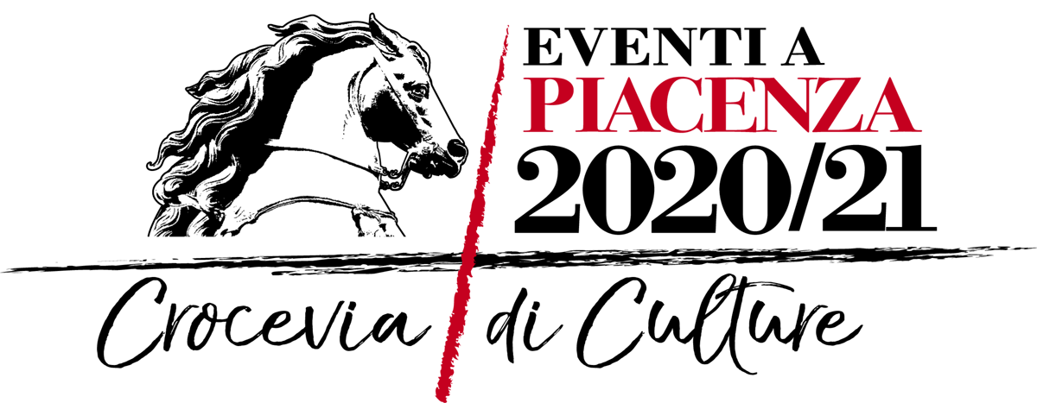

**PIACENZA**

**10 OCTOBER - 28 DECEMBER 2020**

***PALADINOPIACENZA***

**IN PIAZZA CAVALLI**

**A NOVEL JUXTAPOSITION OF WORKS BY**

**FRANCESCO MOCHI (1580-1654) AND MIMMO PALADINO**

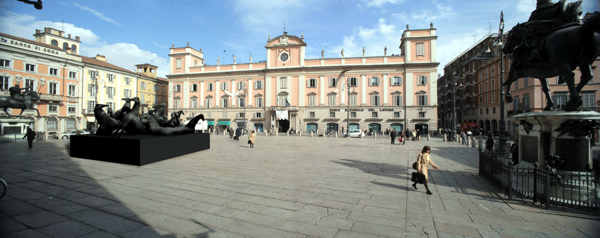

*Digital rendering of the installation*

From **10 October to 28 December 2020**, **Piazza Cavalli** **in the heart of Piacenza** will host ***PaladinoPiacenza***, an initiative curated by Flavio Arensi and Eugenio Gazzola, that will provide a new and fascinating opportunity to compare the works of two masters of modern and contemporary art: **Francesco Mochi** from Montevarchi (1580-1654) and **Mimmo Paladino** (Paduli, Benevento, 1948).

The bronze equestrian statues of Alessandro and Ranuccio I Farnese that Mochi produced between 1612 and 1628, which are undisputed masterpieces of Baroque sculpture and are one of the symbols of Piacenza, will be juxtaposed with a large installation created specifically for this purpose by Paladino, one of the best-known exponents of Italian art on an international level.

*PaladinoPiacenza* is part of the ***Piacenza 2020/21*** programme promoted by a committee composed of the Municipality of Piacenza, the Fondazione di Piacenza e Vigevano, the Diocese of Piacenza-Bobbio and the Piacenza Chamber of Commerce. It focuses on the “Crossroads of cultures” theme that Piacenza adopted in its candidacy for the title of Italian capital of culture.

**Mimmo Paladino’s contribution is a monumental installation** positioned in the centre of Piazza Cavalli, midway between Francesco Mochi’s two equestrian monuments. It is **composed of 18 fibreglass sculptures**, mounted on a 12 metre-square plinth.

The work reprises one of Paladino’s characteristic icons, based on an Etruscan funerary model of a horse that, depending on its surroundings, takes on a Homeric, rural, courtly, migratory or military quality.

The horse is used as a formal element of transition between the ancient and modern worlds, and also as the place where the Eastern and Western civilisations are as one and also at odds.

In the case of *PaladinoPiacenza*, there is an obvious desire to interact with the Farnese monuments that give the city’s central square its name, countering the splendour of Mochi’s sculptures with the rigour of Paladino’s stylised forms.

As Flavio Arensi notes, “Paladino once again proves himself capable of intervening in complex spaces where history reveals itself as a harmonious accretion and where the contemporary artwork becomes a place of interconnection, in its ability to create an entirely autonomous visual and cultural short-circuit. Indeed, one of the salient features of Paladino’s language is that it is able to grasp the overall leitmotifs that characterise a given setting and use them in a free and self-sufficient manner to construct a new story through images.”

“As with other installations, such as the *Montagna di sale* or the large *Croce* in Florence, the work is temporary and remains a sort of ephemeral apparition, a fleeting element that absorbs the pre-existing conditions. The whole square thus becomes a work by Paladino, a symphony between the parts and the people that occupy it,” concludes Arensi.

The two equestrian monuments located in Piazza Cavalli are the work of Francesco Mochi, the Tuscan sculptor from Montevarchi (1580-1654), who took sixteen years, from 1612 to 1628, to produce them. Ranuccio Farnese is depicted in Roman garb and modelled in a classical manner; but his father Alessandro is rendered in a much more mature style, imbued with a spirited dynamism reflected in the billowing mantle and caparison – details that reveal his clearly updated style, prefiguring the great masterpieces of Bernini.

Piacenza, September 2020

***PALADINOPIACENZA***

Piacenza, Piazza Cavalli

**10 October – 28 December 2020**

**Press office**

**CLP Relazioni Pubbliche**

Stefania Rusconi | Tel. 02.36755700 | stefania.rusconi@clp1968.it | www.clp1968.it

**Press release and images on** **www.clp1968.it**