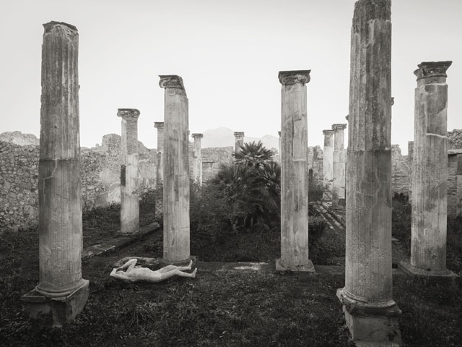
KENRO IZU
Requiem for Pompei
6 December 2019
3 May 2020

FMAV MATA – Ex Manifattura Tabacchi
via della Manifattura dei Tabacchi 83, Modena

MODENA
FMAV MATA – EX MANIFATTURA TABACCHI
EXTENDED UNTIL 3 MAY 2020
THE EXHIBITION OF
KENRO IZU
REQUIEM FOR POMPEI
Curated by Chiara Dall’Olio and Daniele De Luigi

The exhibition presents 55 previously unseen photographs donated by the Japanese artist to the Fondazione di Modena, in a lyrical vision of what was left behind in Pompeii the day after the eruption in 79 AD.
Modena is continuing to forge a special relationship with photography. Now one of the top locations in Italy for this particular form of expression, it is capable of influencing the city’s whole cultural scene thanks to the contribution of institutions such as the Galleria Civica and Fondazione Fotografia Modena, which merged in 2017 to become Fondazione Modena Arti Visive.
From 6 December 2019 to 3 May 2020, Fondazione Modena Arti Visive is hosting a captivating exhibition dedicated to Pompeii, curated by Chiara Dall’Olio and Daniele De Luigi, at one of its venues: FMAV MATA – Ex Manifattura Tabacchi. The exhibition is co-promoted by Pompeii Archaeological Park which is lending some reproductions of the famous plaster casts of the victims of the eruption for the occasion and will then host the exhibition on site in Pompeii.
Headlining the exhibition is Japanese photographer Kenro Izu (Osaka, 1949), whose lasting fascination with the remnants of ancient civilizations has led to the creation of a series of images captured at the most important and best-known archaeological sites in the world, from Egypt to Cambodia, Indonesia to India, Tibet to Syria.
In Modena, Kenro Izu will be presenting Requiem for Pompei, a project he began in 2015, in collaboration with Fondazione Fotografia Modena, dedicated to the Campanian city destroyed by the eruption of Vesuvius in 79 AD and buried under ash and rock. The excavations brought to light not only buildings, but also the exact forms of the bodies of the inhabitants at the moment of their deaths, captured by making casts of the gaps left by their frames under the hardened layer of detritus.
The exhibition proposes a selection of 55 previously unseen images which Kenro Izu has donated to Fondazione di Modena. In the photographs, in a poetic gesture of compassion, the artist has set out copies of the original casts of the bodies, white human shapes which stand out against the ruins of Pompeii.
Kenro Izu’s aim is not to document the remains of Pompeii, but, by emphasizing the idea of what was left behind the day after the eruption of Vesuvius, to transmit the atmosphere – in part wonderment, in part destruction – given off by the ruins.
“Kenro Izu,” in the words of curators Chiara Dall’Olio and Daniele De Luigi, “has the extraordinary ability to bring down the walls of time, by creating sublime images that link our spirits to those of the people of past times, places and civilizations. His prayer for Pompeii brings us close to the victims of that distant tragedy, but, as the artist underlines, at the same time it reminds us of similar calamities that could happen at any time and in any place in the world today.”
As Daniele Pittèri, the director of Fondazione Modena Arti Visive, states “also thanks to the extraordinary black and white of his images, so vivid and painful, Kenro Izu composes the score for a requiem for contemporary civilization through the human traces that he scatters among the ruins of Pompeii, swept away by the violence of nature. Now another catastrophe is looming, not just at the hand of a constantly ill-treated nature, which sooner or later will seek its comeuppance, but also at the hand of a human atrocity presently fuelled by destructive anxiety. Kenro Izu uses the contrast between the immobility of the petrified human bodies and the monumental ruins which have become part of the landscape and surrounding nature, along with the ‘definitive’ staticity of his images, to imagine a bitter future for humankind, with its obliviousness to the past and inability to realize the consequences of its actions.”
“The plaster casts of Pompeii, brainchild of Giuseppe Fiorelli, have always aroused curiosity and at times morbosity among visitors. We are able to remember and pity the victims of the eruption thanks to this shape that he managed to give to the pain of death,” underlines Massimo Osanna, Director of Pompeii Archaeological Park. “So Pompeii is already a Requiem for those who experienced that tragedy. Even more, however, it is a reflection on humankind’s smallness and our impotence before our fate. With his touching photographs, maestro Kenro Izu manages to rekindle this profound sense of compassion towards human drama preserved by the ancient city, at times obscured by its touristic side and the masses of visitors. We are strongly committed to opening the Archaeological Park to all forms of contemporary art, from painting to sculpture and photography, to underline that Pompeii is not just testimony to a civilization, it is also a symbol, a reflection on life and death, as seen through the eyes of every era and artist.”
Kenro Izu, who will be visiting professor for the Master’s in Contemporary Images at FMAV - School of Advanced Studies, will be appearing in the artist talk “Kenro Izu: Pompei tra storia, materia e spirito”, in dialogue with the curators of the exhibition, at 6 pm on Wednesday 11 December at FMAV – MATA.

Biographical notes
Kenro Izu (1949, Osaka) began to take photographs in the 1960s, completing his training at the Nihon University College of Arts in Tokyo. In 1970, he moved to New York, where he still lives and works today. In 1979, he made his first trip to Egypt and, amazed by the immenseness of the pyramids and the sense of transcendence communicated by the ruins, he started one of his most famous series, Sacred Places, which over the following decades would take him to photograph the most important archaeological sites in the world, from Cambodia to Tibet, India to Europe, to Mexico, Peru and the Easter Island.
Fascinated by the sublime beauty of these traces of ancient times, he found in the styles and printing techniques of nineteenth-century photography the most suitable means to impress in his images the magical atmospheres of the places he encountered. His photographs are platinum prints, cyanotypes and silver gelatin prints, which the artist makes by hand in the dark room from large-format negatives. His works have been presented in numerous solo and group exhibitions, organized at the Rubin Museum of Art, New York (2004), the Tokyo Metropolitan Teien Art Museum (2005), the University of Kentucky Art Museum in Lexington (2007), the Detroit Institute of Art, the Kiyosato Museum of Photographic Art in Yamanashi, Japan (2008) and the Museum of Photographic Arts, San Diego (2009).
His works are preserved in the photographic collections of the Boston Museum of Art, Canadian Center for Architecture, J. Paul Getty Museum, Galleria Civica Modena, Houston Museum of Fine Art, Kiyosato Museum of Photographic Arts, Metropolitan Museum of Art, Museum of Photographic Arts, San Francisco Museum of Modern Art, Santa Barbara Museum of Arts and Tokyo Metropolitan Museum of Photography.

KENRO IZU. Requiem for Pompei
FMAV MATA - Ex-Manifattura Tabacchi
via della Manifattura dei Tabacchi 83, Modena

Opening
Friday 6 December 2019, 6 pm

Dates
7 December 2019 – 3 May 2020

Curated by
Chiara Dall’Olio and Daniele De Luigi

Produced by
Fondazione Modena Arti Visive

Co-promoted by
Pompeii Archaeological Park

Opening hours
Wednesday, Thursday and Friday: 11 am-1 pm / 4-7 pm; Saturday, Sunday and bank holidays: 11am-7pm
Open 25 December and 1 January: 4-7pm

Entrance
Full price € 6.00| Reduced € 4.00
Free entry: Wednesday | first Sunday of month
Buy online on Vivaticket

Information
Tel. +39 059 2032919 | www.fmav.org

FONDAZIONE MODENA ARTI VISIVE press office
Irene Guzman | T. +39 349 1250956 | i.guzman@fmav.org

Press office
CLP Relazioni Pubbliche | Stefania Rusconi | tel. 02.36755700 | stefania.rusconi@clp1968.it | www.clp1968.it

